

Local Government (Miscellaneous Provisions) Act 1982
Section 2 and Schedule 3 (Licensing of Sex Establishments)

APPLICATION FOR GRANT/RENEWAL/TRANSFER OF A SEX ESTABLISHMENT LICENCE

I/WE HEREBY APPLY to Lichfield District Council to grant/renew/transfer a licence to use a premises/a vehicle/vessel or a stall as a sex shop

PLEASE COMPLETE THIS FORM IN BLOCK LETTERS
(CONTINUE ON A SEPARATE SHEET IF NECESSARY)

TYPE OF SEX SHOP LICENCE APPLYING FOR:

GRANT RENEWAL TRANSFER

THIS SECTION NEED ONLY BE ANSWERED WHERE THE APPLICANT IS AN INDIVIDUAL

If the application is made on behalf of an individual please state:

Full name(s) of applicant:……………………………………………………………………………..

State any other name or names by which the applicant is, or has been, known:
……………………………………………………………………………………………………………

Permanent Address:.…………………………………………………………………………………..

……………………………………………………………………………………………………………

Telephone No:.…………………………………………………………………………………………

YES NO

Have you resided at the address given above throughout the whole
of the six months immediately preceding the making of this application?

If the answer is “NO” please give all other addresses at which you have resided during that time:……………………………………………………………………………………………………...

……………………………………………………………………………………………………………

Age:……………………… Date of Birth:………………………..Place of birth:……………………
Has the applicant a financial interest in the business that is the subject of this application (state nature of interest)?

…………………………………………………………………………………………………………...

……………………………………………………………………………………………………………

THIS SECTION NEED ONLY BE ANSWERED WHERE THE APPLICANT IS A COMPANY

If application is made on behalf of a corporate or unincorporated body please state:

Full name of body:……………………………………………………………………………………..

Address or registered or principal body:……………………………………………………………..

……………………………………………………………………………………………………………

Telephone No:………………………………………………………………………………………….

Give full names and private addresses of all directors or other persons responsible for management of the establishment:

Full name…………………………………………………………………………………………

Permanent Address……………………………………………………………………………..

…………………………………………………………………………………………………….

Age…………………Date of Birth……………………………Place of birth………………….

Full name…………………………………………………………………………………………

Permanent Address……………………………………………………………………………..

…………………………………………………………………………………………………….

Age…………………Date of Birth……………………………Place of birth………………….

Full name…………………………………………………………………………………………

Permanent Address……………………………………………………………………………..

…………………………………………………………………………………………………….

Age…………………Date of Birth……………………………Place of birth………………….

Full name…………………………………………………………………………………………

Permanent Address……………………………………………………………………………..

…………………………………………………………………………………………………….

Age…………………Date of Birth……………………………Place of birth………………….

Is the applicant a wholly or partly owned subsidiary of another Company?

………………………………………………………………………………………………………..

What type of Company is the applicant (e.g. public or private limited by share or guarantee etc)?

…………………………………………………………………………………………………………..

……………………………………………………………………………………………………………

In which country is the Company incorporated?

……………………………………………………………………………………………………………

What is the date of incorporation of the Company?

……………………………………………………………………………………………………………

Supply a certified copy of the applicant Company’s Memorandum and Articles

If the applicant is a subsidiary of another Company give the details and information:

A certified copy of the Memorandum and Articles of the parent company
A list of all other companies controlled by the parent company together with full details of any ultimate holding company
The name and private addresses of the Directors and Company Secretary of the parent company (use a separate sheet if necessary).

OTHER INTERESTED BODIES

YES NO

Has any person or body other than the applicant have any interest in
the business, whether by sharing in gross returns, or in profits or
losses, or by way of annuity loan or otherwise?

If the answer is “Yes” please state names and addresses of the holders of such interests and the nature and extent or such interests.

…………………………………………………………………………………………………………..

……………………………………………………………………………………………………………

YES NO

Is the business in respect of which this application is made required to
purchase merchandise solely or mainly from a particular company or
body?

If the answer is “Yes” supply a copy of any agreement and state what is to be purchased and from whom

…………………………………………………………………………………………………………..

…………………………………………………………………………………………………………..

DETAILS OF CONVICTIONS

Have you any convictions recorded against you? Or in a body corporate or unincorporated body that body or any of its directors or other persons responsible for its management? If so, please state:
N.B. All convictions must be disclosed unless spent, see notes below for spent convictions which should not be included.

Date Of Conviction | Offence | Sentence (including suspended sentence)

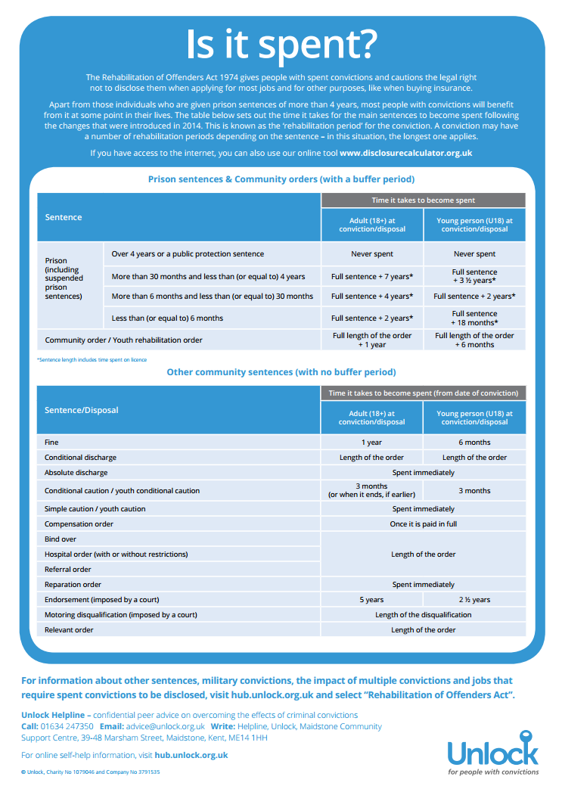

Is there in force against the applicant or any of the persons whose

YES NO

names appear in this application form a disqualification from holding
a licence for a sex establishment under the Local Government
(Miscellaneous Provisions) Act 1982?

If “yes” give full details:……………………………………………………………………………….

…………………………………………………………………………………………………………..

Please disclose any Forfeiture Order made under the Obscene Publications Act, 1959, made in respect of any articles seized from premises where the applicant or any person named in this form was carrying on a business:

……………………………………………………………………………………………………………

THE PREMISES

State whether this application is in respect of:

- Premises
- Vehicle
- Vessel
- Stall

In the case of premises state the full address, for a vehicle state registration number, make and type, for a vessel state name and give a brief description, for a stall give a brief description.

……………………………………………………………………………………………………………

……………………………………………………………………………………………………………

If the application relates to a vehicle, vessel or stall state where it is to be used as a sex shop.

……………………………………………………………………………………………………………

……………………………………………………………………………………………………………

If the application relates to a premises state whether the applicant is the freeholder or the leaseholder

……………………………………………………………………………………………………….

If the applicant is the leaseholder state:
- the name and address of the lessor; and
- the annual rent paid for the premises to which the application relates (If the rent also relates to other premises please describe the premises).

……………………………………………………………………………………………………………

……………………………………………………………………………………………………………

Are the whole of the premises described above to be used as a sex shop? YES NO

If “No” which parts of the premises are to be used for the purposes of a sex shop:

……………………………………………………………………………………………………………

What use is the remainder of the premises to be put?

……………………………………………………………………………………………………………

Give the names of those responsible for the management of the remainder of the premises:

……………………………………………………………………………………………………………

Please give details of the type of product that will be offered for sale:………………………...

……………………………………………………………………………………………………………

……………………………………………………………………………………………………………

Are the premises, or the vehicle, vessel or stall for which this application is made, in use as a sex establishment at the date of this application?

……………………………………………………………………………………………………………

……………………………………………………………………………………………………………

Under what name are or will the premise be known?……………………………………………...

……………………………………………………………………………………………………………

Give details of the days and times during which it is proposed that the establishment is to be opened to the public:

……………………………………………………………………………………………………………

……………………………………………………………………………………………………………

Is there any further information that the applicant would wish the Council to take into account when considering this application?

……………………………………………………………………………………………………………

……………………………………………………………………………………………………………

APPLICANTS ARE WARNED THAT ANY PERSON WHO, IN CONNECTION WITH A APPLICATION FOR THE GRANT, RENEWAL OR TRANSFER OF A LICENCE MAKES A FALSE STATEMENT WHICH HE/SHE KNOWS TO BE FALSE IN ANY MATERIAL RESPECT, OR WHICH HE/SHE DOES NOT BELIEVE TO BE TRUE, IS GUILTY OF AN OFFENCE AND LIABLE ON SUMMARY CONVICTION TO A FINE.

DECLARATION

I ………………………………………………declare that I believe the information given is true and complete in every respect.

Signature of applicant: ………………………………………

Date: …………………….

(Where the applicant is a body corporate or unincorporated body this application should be signed by a partner, the secretary or a director stating in which capacity it is signed).

Local Government (Miscellaneous Provisions) Act 1982
Section 2 and Schedule 3 (Licensing of Sex Establishments)

GUIDANCE NOTES FOR APPLICANTS FOR GRANT, RENEWAL, TRANSFER OR VARIATION OF SEX SHOP LICENCE

Under the provision of the above legislation any person who intends to use any premises, vehicle, vessel or stall as a sex establishment within the area of Lichfield District Council must first obtain a Sex Shop Licence from Lichfield District Council.

Failure to obtain such a licence could result in prosecution and a fine.

- Notification of intention to apply for the grant, renewal or transfer of a licence must be given no later than 7 days after the date of the application to The Chief Officer of Police-
Staffordshire Police Licensing
Early Intervention and Prevention Unit
Block 9 Ground Floor
Weston Road
Staffordshire ST18 0YY
Email: licensinghq@staffordshire.pnn.police.uk

- A copy of the notice of application for a sex establishment licence must be completed separately and displayed on or near the premises and in a place that can be conveniently read by the public. The notice must be displayed for 21 days beginning with the date of the application.

- At least 28 days prior to opening or twenty-eight days prior to the expiry of the current licence, formal application for the licence, together with the appropriate fee, must be made to Licensing . A licence will not be issued until at least twenty-eight days has elapsed.

- The appropriate licence fee should accompany the application:

New: £1650
Renewal: £ 930
Transfer: £ 310
Variation: £ 330

NB- an administration fee of £1000 will be levied on applications that are refused or withdrawn for all new licence applications.

- Notice shall in all cases be given by publishing an advertisement in a local newspaper circulating in the appropriate authority’s area. The publication shall not be later than 7 days after the date of the application. A complete copy of the page of the newspaper circulating in the Council’s area in which notice of the application has been published in accordance with paragraph 10(8) of Schedule 3 to the Local Government (Miscellaneous Provisions) Act 1982. Photocopies of the newspaper will not be accepted.

- In the case of an application for the grant of a licence (but not for a renewal or transfer) a scale plan of the premise, vehicle, vessel or stall in respect of which the application is made, showing:

  - all means of entrance to and exit from the establishment, and

  - details of how the premises are situated in relation to the street and the front elevation of the building.

