District Council House, Frog Lane
Lichfield WS13 6ZE
Telephone: 01543 308999
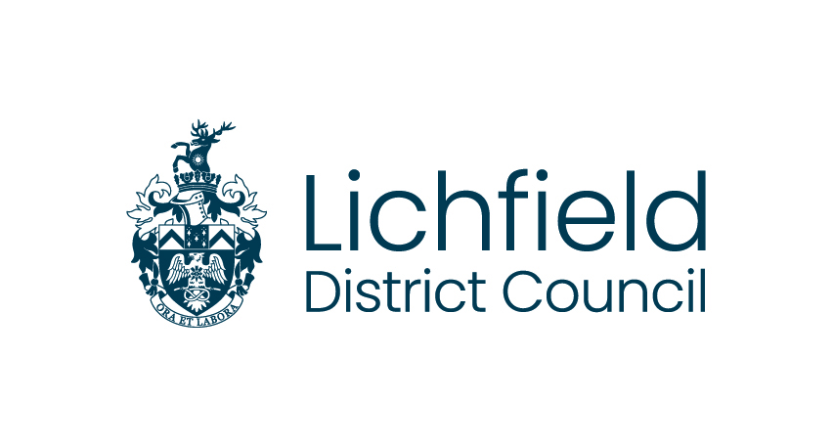
LOCAL GOVERNMENT (MISCELLANEOUS PROVISIONS) ACT 1982
REGISTRATION TO CARRY ON PRACTICE OF SPECIAL TREATMENTS

PREMISE APPLICATION
Trading name of business
Applicants full name
Applicants home address | Address:  Postcode:
Address of premises to be registered | Address:  Postcode:
Business owner (please identify whether sole trader, partnership, ltd company etc)
Business registered office address (where applicable) | Address:  Postcode:
Telephone number for premises
Alternative contact number
E-mail contact
What type of skin treatment is to be undertaken? | Please tick
What type of skin treatment is to be undertaken? |  | Semi-permanent skin colouring
What type of skin treatment is to be undertaken? |  | Acupuncture
What type of skin treatment is to be undertaken? |  | Cosmetic Piercing
What type of skin treatment is to be undertaken? |  | Electrolysis
What type of skin treatment is to be undertaken? |  | Tattooing
Your application must include:
- A premises/ studio plan
- Method for cleansing, disinfection, and sterilisation of equipment, fittings, and the premises.
- Policy in respect of proof of age checks
- Client consent form
- After care advice sheet
I declare that the above information is correct to the best of my knowledge and undertake to inform the council of any changes in these particulars
Signature of applicant: |  |  |  | Date:
Full name: |  |  | Position held:
Payment
Registration will not be completed without the appropriate registration fee. The current registration fee for premises licences is £190.00. To pay by debit/credit card call 01543 308729
RETURN TO: ENVIRONMENTAL HEALTH, LICHFIELD DISTRICT COUNCIL, DISTRICT COUNCIL HOUSE, FROG LANE, LICHFIELD, WS13 6ZE or email OccupationalS@lichfielddc.gov.uk

