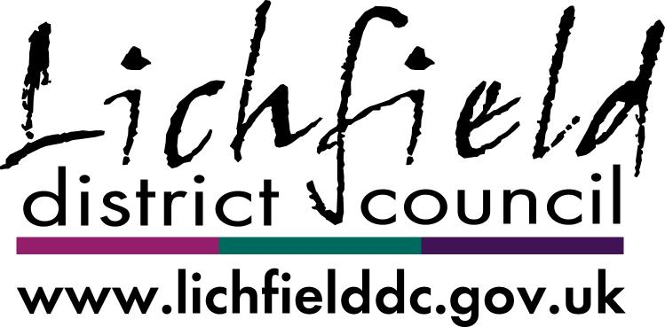

Land Charges
Search Request Form

This form may be used for all search requests. Please provide full details, description of the land/property to be searched and a plan indicating boundaries.
Email landcharges@lichfielddc.gov.uk
Phone: 01543 309819
Post Land Charges, Lichfield District Council, District Council House, Frog Lane, Lichfield, Staffordshire, WS13 6YZ
Account No. | Company/Name and Address |  |  |  |  |  |  |  | Your Reference
Account No. | Your telephone number |  |  |  |  |  | Email address
Description of property/land to be searched against |  |  |  |  |  |  |  | For identification purposes please supply a plan of the site to be searched

Official Local Authority Search Requests (CON29)
Residential Dwelling |  |  |  |  |  | Non-Residential
Full Residential Search  (LLC1 & Con29 Required form) @ £155.00 |  |  |  |  |  | Full Commercial Search  (LLC1 & Con29 Required form) @ £262.00
Residential LLC1 Search  @ £35.00 |  |  |  |  |  | Commercial LLC1 Search  @ £40.00
Con 29 Optional Questions
Con 29  Optional Questions  @ £42.00 each  Total Fee to be paid/ invoiced  £ |  |  | 4 | Road proposals by Private Bodies
 |  |  | 5 | Advertisements
 |  |  | 6 | Completion Notices
 |  |  | 7 | Parks and Countryside
 |  |  | 8 | Pipelines
 |  |  | 9 | Houses in Multiple Occupation
 |  |  | 10 | Noise Abatement
 |  |  | 11 | Urban Development Areas
 |  |  | 12 | Enterprise Zones, Local Development Orders & BIDs
 |  |  | 13 | Inner Urban Improvement Areas
 |  |  | 14 | Simplified Planning Zones
 |  |  | 15 | Land Maintenance Notices
 |  |  | 16 | Mineral Consultation Areas
 |  |  | 17 | Hazardous Substances Consents
 |  |  | 18 | Environmental and Pollution Notices
 |  |  | 19 | Food Safety Notices
 |  |  | 20 | Hedgerow Notices
 |  |  | 21 | Flood Defence and Land Drainage consents
 |  |  | 22 | Common Land & Town or Village Green

